Visualizing Spatiotemporal Traffic Congestion Patterns Using Dynamic Folium and Mapbox Layers: A Case Study of Metropolitan Bus Transit Networks
Mayur Sanjay Nakate
Department of Computer Science, Faculty of Science & Technology, Vishwakarma University, Pune, India
SRN: 31242345 | 31242345@vupune.ac.in | Guided by Dr. Anupriya Kamble
Abstract—Metropolitan bus transit depends on reliable operation, yet mixed traffic produces congestion bottlenecks that delay buses and weaken schedule reliability. Conventional GIS views rely on static choropleth maps and aggregated statistics, which hide how congestion propagates over space and time. This paper presents a visual analytics framework that combines normalized congestion indices (the Speed Performance Index, Transit Congestion Index and delay-rate deficit) with Haversine DBSCAN clustering and a dual dynamic cartographic pipeline built on Folium (HeatMapWithTime and AntPath) and Mapbox GL (PyDeck 3D hexagon layers), delivered through a Streamlit dashboard. The framework is demonstrated on 34,441 synthetically generated GPS records covering 4 arterial corridors and 18 stations of a modeled Pune network between 07:00 and 22:00. Mean network speed fell from 41.8 km/h at 07:00 to 24.2 km/h at 09:00 (a 42.1% drop) and to 21.5 km/h at 18:00. DBSCAN isolated five persistent chokepoints with mean speeds of 7.6–11.4 km/h and speed degradation of 75.2–83.1%, ranked by a Bottleneck Severity Score from 63.4 to 143.5. Mapbox GL rendered at 165 ms and 60 FPS, and the Folium temporal heatmap at 310 ms and 48–55 FPS. Because the trajectories are simulated, the results demonstrate the analytical and visualization pipeline rather than measured conditions on Pune’s streets.
Keywords—spatiotemporal traffic congestion, bus transit networks, dynamic heatmaps, trajectory vectors, Folium, Mapbox GL, DBSCAN clustering, Speed Performance Index, Streamlit, intelligent transportation systems.

Introduction
Urban bus transit carries millions of commuters every day in Indian metropolises such as Pune and Mumbai. As vehicle density grows, buses share arterial roads with general traffic, and chokepoints such as busy intersections, flyover merges and bridge crossings cause bus bunching, unreliable schedules and higher operating costs. Transit planners therefore need to know not only that congestion occurs but where it forms, when it peaks and how long it lasts.
Modern fleets record Automated Vehicle Location (AVL) data as GPS trajectories at high frequency, but the maps commonly used to inspect them are static choropleth layers or averages over fixed road segments. These views hide two dynamics that matter for operations: the spatial spread of slow traffic along a corridor, and its evolution through the day between peak and off-peak periods. Web mapping libraries now make it possible to show both interactively in the browser.
This paper presents a spatiotemporal visualization and analysis framework for metropolitan bus networks. It computes normalized congestion indices, isolates persistent bottlenecks with density-based clustering, and renders the results with two complementary map pipelines in a single dashboard. The framework is demonstrated on a synthetic trajectory dataset for a modeled Pune network, and this is stated throughout: the findings validate the pipeline, not real traffic conditions. Section II lists the objectives and contributions, Section III reviews related work, Section IV describes the data, Section V the methodology, Section VI the implementation, Section VII the results, Section VIII the limitations, and Section IX concludes with future scope.

Objectives and Contributions
The objective is to develop an interactive, data-driven spatiotemporal visualization and analytical system that monitors congestion dynamics and identifies structural bottlenecks in metropolitan bus transit networks. The system processes AVL-style GPS trajectory streams across multiple corridors, computes normalized congestion performance indices, isolates persistent bottlenecks by density-based clustering, and presents the results on dynamic maps. Unlike dashboards that show static routes or historical average travel times, it combines client-side Leaflet temporal slicing with GPU-accelerated Mapbox GL rendering. The main contributions are:
(1) A normalized index suite (Speed Performance Index, Transit Congestion Index and delay-rate deficit) that measures speed degradation relative to free-flow speed.
(2) An unsupervised bottleneck detection step using Haversine DBSCAN, with a Bottleneck Severity Score (BSS) to rank the clusters found.
(3) A dual dynamic visualization pipeline: Folium HeatMapWithTime playback and AntPath directional vectors, plus Mapbox GL 3D extruded hexagon density columns.
(4) A demonstration on 34,441 synthetic GPS records over 4 corridors and 18 stations, in which five persistent chokepoints are isolated.
(5) An interactive Streamlit dashboard with live filters, executive KPIs and GeoJSON and CSV export for QGIS and ArcGIS Pro.
Together these give planners an evidence-based way to locate chokepoints, which can inform measures such as Transit Signal Priority (TSP) and schedule adjustment.

Related Work
Zheng’s survey of trajectory data mining [1] covers the main stages of working with GPS traces, including preprocessing, map matching and pattern discovery, and provides the background for treating bus pings as a spatiotemporal stream. Congestion itself can be quantified in several ways; the survey of Afrin and Yodo [5] reviews speed-based and delay-based congestion measures, which motivates the normalized speed and delay indices used here.
To locate bottlenecks without labeled data, a density-based method is attractive. DBSCAN [2] groups points that are densely packed, finds clusters of arbitrary shape and labels sparse points as noise, without fixing the number of clusters in advance. It is available in scikit-learn [6], whose implementation supports the Haversine metric needed for latitude and longitude data.
On the visualization side, Wood et al. [3] showed how origin-destination maps can display flows compactly, and Ferreira et al. [4] built interactive visual queries over a large set of New York City taxi trips, illustrating the value of interactivity for big spatiotemporal data. Table I relates these works to the present study.
TABLE I
Related work compared with this study
Ref. | Focus | Gap relative to this study
[1] | Trajectory data mining overview | General methods; no interactive transit congestion maps
[2], [6] | Density-based clustering and its implementation | Generic algorithm; not tied to speed indices or severity ranking
[3], [4] | Flow and big urban data visualization | Focus on OD flows and taxi trips; no bus bottleneck scoring
[5] | Survey of congestion measures | Defines indicators; no spatiotemporal visual delivery
This study | Integrated analytics | Combines indices, Haversine DBSCAN, Folium and Mapbox GL layers in one dashboard

Dataset
The dataset consists of 34,441 GPS trajectory records for a modeled Pune bus network with 4 arterial corridors and 18 transit stations, covering 07:00 to 22:00 (15 operating hours) at 30-second sampling. The records are synthetic: the data generator takes the corridor definitions and waypoint sequences, applies road-geometry jitter and simulates vehicle movement. Each record holds the timestamp, vehicle_id, route_id, latitude and longitude, speed_kmh, free_flow_speed, SPI, schedule_delay_sec and passenger_load. Because the data are generated, the bottlenecks found in Section VII reflect the simulated network and not measured traffic.

Methodology

Workflow
The framework follows the nine steps in Fig. 1. The network is modeled, trajectories are prepared, performance indices are computed, and exploratory analysis produces hourly corridor velocity profiles, schedule-delay curves and route-by-hour heatmap matrices. Congested points are then clustered, the clusters are quantified, and the results are rendered on dynamic maps in a Streamlit application.
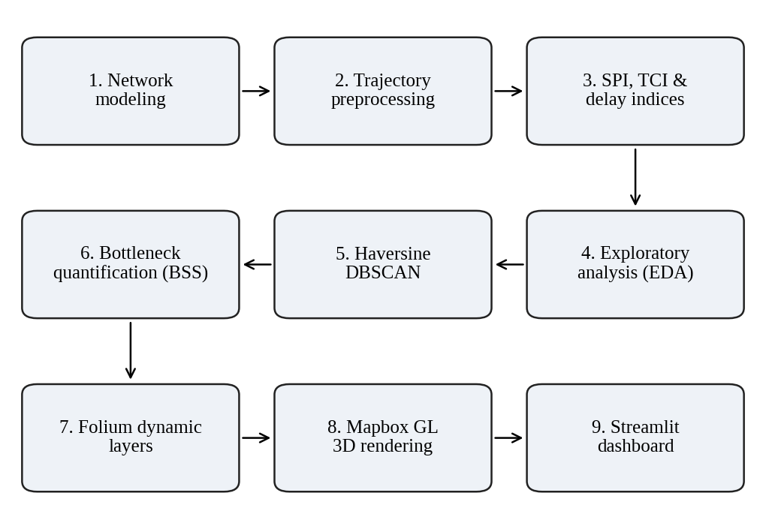
Fig. 1. Workflow of the spatiotemporal congestion analysis and visualization framework.

Congestion Performance Indices
For an observed speed v and corridor free-flow speed v_{ff}, the Speed Performance Index, Transit Congestion Index and delay-rate deficit (in s/km) are
SPI = 100·v / v_{ff} (1)
TCI = max(0, 1 − v / v_{ff}) (2)
Δτ = 3600 / v − 3600 / v_{ff} (3)
Because each index is relative to free-flow speed, corridors with different speed limits can be compared on one scale.

Haversine DBSCAN Clustering
Candidate congested samples are those with SPI ≤ 35%. Their latitude and longitude are converted to radians and clustered with DBSCAN [2] using a BallTree and the Haversine distance, with radius eps = 350 m and MinPts = 25. The Haversine distance between two points is
d_{H} = 2R arcsin(√h) (4)
where R is the Earth radius and h = sin²(Δφ/2) + cos φ₁ cos φ₂ sin²(Δλ/2), with φ the latitude and λ the longitude. Clusters of dense congested points correspond to recurrent chokepoints, while isolated slow points are treated as noise.

Bottleneck Quantification
For each cluster the centroid, the 90th-percentile impact radius and the mean speed drop are computed, together with the Bottleneck Severity Score
BSS_{j} = (1 − S_{j}/100)·ln(N_{j} + 1)·(H_{j}/15)·20 (5)
where S_{j} is the mean SPI of cluster j, N_{j} its number of points, and H_{j} the number of operating hours in which it is active, normalized by the 15-hour operating window. A cluster therefore scores higher when speeds are lower, when it contains more congested points and when it persists for longer.

Dynamic Cartography
Two map pipelines are used. Folium [7] builds indexed temporal arrays for HeatMapWithTime, weighted by TCI, and animated AntPath lines that show the direction of vehicle flow. Mapbox GL [8], used through PyDeck [9], builds 3D extruded hexagon columns whose height reflects congestion density, and 3D paths rendered with WebGL shaders.

System Implementation
The system is written in Python and organized into the modules listed in Table II. It was developed in Visual Studio Code with Python 3.14.0 and Streamlit 1.65.0 [10], using Folium 0.20.0, PyDeck 0.9.3, Streamlit-Folium 0.27.4, Branca 0.8.2, Pandas 2.3.3, NumPy 2.4.0, scikit-learn 1.8.0, SciPy 1.17.1, Shapely 2.2.0, Plotly 7.1.0 and Matplotlib 3.10.8. The hardware was an Intel Core i7 or AMD Ryzen processor with 16 GB of RAM and a WebGL2-capable GPU. The pipeline is run with “python run_pipeline.py” and the dashboard with “streamlit run app.py”.
TABLE II
Software modules and roles
Module | Role
src/data_generator.py | Corridor ingestion, road-geometry jitter, trajectory simulation
src/congestion_analyzer.py | SPI, TCI and delay indices; Haversine DBSCAN; BSS
src/folium_layers.py | HeatMapWithTime, AntPath vectors, station nodes
src/mapbox_layers.py | 3D HexagonLayer and 3D paths (PyDeck)
app.py | Streamlit dashboard: seven tabs, KPIs, Plotly analytics, exporter
run_pipeline.py | End-to-end pipeline execution

The dashboard shows four executive indicators: the number of trajectory pings, the mean network speed, the mean SPI and the number of bottleneck zones detected. Plotly provides the speed and delay analytics, and the Folium and Mapbox GL layers are embedded alongside them.

Results and Discussion

Network Speed Profile
The simulated network shows a pronounced two-peak pattern of congestion (Fig. 2). Mean speed is 41.8 km/h at 07:00, when traffic is free flowing, and falls to 24.2 km/h at the 09:00 morning peak, a drop of 42.1%. It recovers to 37.1 km/h at midday and then falls to 21.5 km/h at 18:00, the lowest of the reported times and a drop of about 48.6% from the 07:00 level.
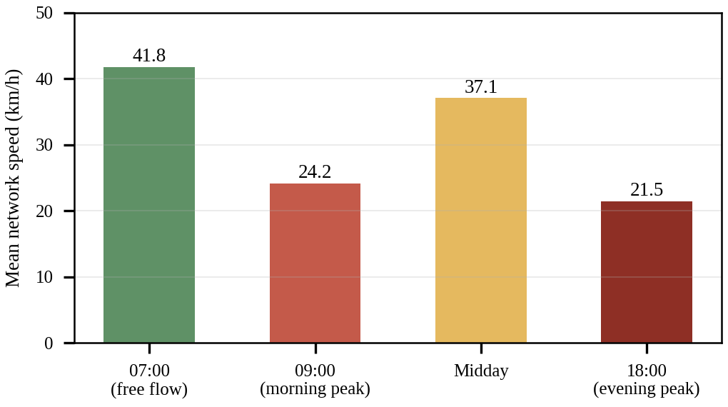
Fig. 2. Mean network speed at the reported times of day.

Detected Bottlenecks
Haversine DBSCAN isolated five persistent chokepoint zones, summarized in Table III and ranked in Fig. 3. All five show speed degradation above 75%, with mean speeds between 7.6 and 11.4 km/h.
TABLE III
Persistent bottlenecks detected by DBSCAN
ID | Zone | Radius | Avg speed | Speed drop | Peak hr | BSS
BN-01 | Central CBD arterial intersection | 350 m | 8.2 km/h | −82.9% | 20:00 | 143.5
BN-02 | Tech corridor and flyover merge | 450 m | 9.6 km/h | −80.0% | 10:00 | 76.2
BN-03 | Railway station terminal | 400 m | 7.6 km/h | −83.1% | 10:00 | 122.7
BN-04 | University circle rotary | 380 m | 8.1 km/h | −82.4% | 17:00 | 122.1
BN-05 | River bridge crossing | 500 m | 11.4 km/h | −75.2% | 18:00 | 63.4

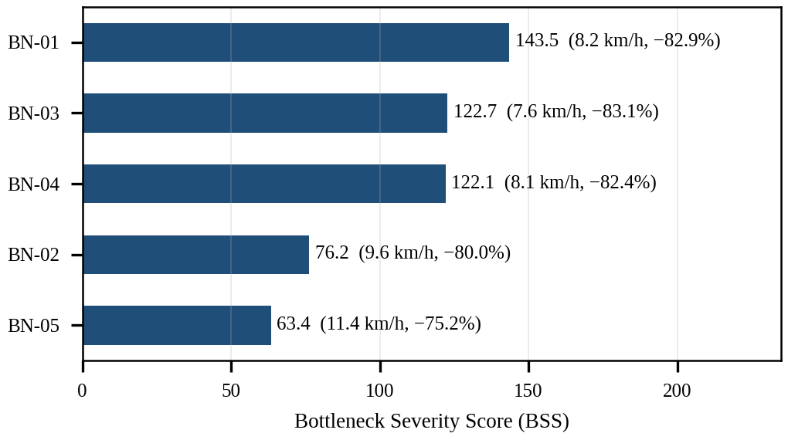
Fig. 3. Bottleneck Severity Score of the five detected chokepoints, with mean speed and speed drop in brackets.
BN-01, the central CBD arterial intersection, has the highest severity (143.5), followed closely by the railway station terminal BN-03 (122.7) and the university circle rotary BN-04 (122.1). BN-03 has the lowest mean speed (7.6 km/h) and the steepest drop (83.1%) yet ranks second, which shows that BSS depends on cluster size and persistence as well as on speed. BN-05, the river bridge crossing, ranks lowest (63.4) with the widest impact radius (500 m) and the mildest drop (75.2%). Peak hours differ by site, from 10:00 for BN-02 and BN-03 to 17:00–18:00 for BN-04 and BN-05 and 20:00 for BN-01, which is the kind of information a planner could use to target signal priority or schedule changes at specific locations and times. These patterns come from simulated data and should be confirmed on real AVL records.

Rendering Performance
Both map pipelines gave sub-second browser performance on the test hardware. The Mapbox GL layer rendered in 165 ms at 60 FPS using WebGL shader instancing, while the Folium HeatMapWithTime layer took 310 ms and animated at 48–55 FPS. Mapbox GL is therefore the better choice for dense 3D views, whereas Folium offers accessible time-slider playback; the dashboard offers both.

Limitations
The main limitation is that the trajectories are simulated, so no claim can be made about actual traffic in Pune, and the five bottlenecks may reflect parameters of the generator. The detection thresholds (SPI ≤ 35%, eps = 350 m, MinPts = 25) and the BSS weighting were not tuned or tested for sensitivity, and no comparison with real AVL data or ground-truth bottlenecks was made. The model covers only four corridors and one city, the rendering benchmarks come from a single hardware configuration, and applications such as Transit Signal Priority were not tested operationally.

Conclusion and Future Scope
This paper presented an integrated spatiotemporal visualization and bottleneck-mining platform for metropolitan bus transit that combines SPI and TCI indices, Haversine DBSCAN clustering and dual Folium and Mapbox GL map layers. On a synthetic Pune network of 34,441 records it reproduced a two-peak congestion profile and isolated five persistent chokepoints with more than 75% speed degradation, with both map pipelines rendering in under a second. The system is therefore a working analytical and visualization prototype, and its value for real operations remains to be shown with measured data.
Future work includes: (1) validating the framework on real AVL data; (2) ingesting live VehiclePosition and TripUpdate feeds through GTFS Realtime [11]; (3) predicting queue build-up with spatiotemporal graph convolutional networks [12]; (4) interfacing Transit Signal Priority with municipal adaptive traffic control systems; (5) fusing smart-card tap demand data for multi-modal analysis; and (6) deploying a mobile progressive web application for depot supervisors.

Acknowledgments
The author thanks Dr. Anupriya Kamble, Department of Computer Science, Faculty of Science & Technology, Vishwakarma University, Pune, for guidance throughout the Research Methodology course.

References
[1] Y. Zheng, “Trajectory data mining: An overview,” ACM Trans. Intell. Syst. Technol., vol. 6, no. 3, pp. 1–41, 2015.
[2] M. Ester, H.-P. Kriegel, J. Sander, and X. Xu, “A density-based algorithm for discovering clusters in large spatial databases with noise,” in Proc. 2nd Int. Conf. Knowl. Discovery Data Mining (KDD), 1996, pp. 226–231.
[3] J. Wood, J. Dykes, and A. Slingsby, “Visualisation of origins, destinations and flows with OD maps,” Cartographic J., vol. 47, no. 2, pp. 117–129, 2010.
[4] N. Ferreira, J. Poco, H. T. Vo, J. Freire, and C. T. Silva, “Visual exploration of big spatio-temporal urban data: A study of New York City taxi trips,” IEEE Trans. Vis. Comput. Graphics, vol. 19, no. 12, pp. 2149–2158, 2013.
[5] T. Afrin and N. Yodo, “A survey of road traffic congestion measures towards a sustainable and resilient transportation system,” Sustainability, vol. 12, no. 11, Art. no. 4660, 2020.
[6] F. Pedregosa et al., “Scikit-learn: Machine learning in Python,” J. Mach. Learn. Res., vol. 12, pp. 2825–2830, 2011.
[7] Folium Developers, “Folium documentation.” [Online]. Available: https://python-visualization.github.io/folium/
[8] Mapbox, “Mapbox GL JS documentation.” [Online]. Available: https://docs.mapbox.com/mapbox-gl-js/
[9] vis.gl, “pydeck documentation.” [Online]. Available: https://deckgl.readthedocs.io/
[10] Streamlit, “Streamlit documentation.” [Online]. Available: https://docs.streamlit.io/
[11] GTFS.org, “GTFS Realtime reference.” [Online]. Available: https://gtfs.org/realtime/
[12] B. Yu, H. Yin, and Z. Zhu, “Spatio-temporal graph convolutional networks: A deep learning framework for traffic forecasting,” in Proc. 27th Int. Joint Conf. Artif. Intell. (IJCAI), 2018, pp. 3634–3640.

